NCI/CBIIT

GreenSheets System
Use-Case Specification: Search and View greensheets

Version 2.1

Prepared for:
The National Institutes of Health
National Cancer Institute
CBIIT

Document Location
Ensure that this document is current. Printed documents and locally copied files may become obsolete due to changes to the master document. The source of this document is located in the Subversion SVN documentation repository at: https://ncisvn.nci.nih.gov/svn/iscs/greensheets/Requirements/Use-cases/Search%20and%20View%20greensheets.doc

Revision History
Version Number | Revision Date | Author | Summary of Changes
1.0 | 5/03/2017 | G. Tulchinskaya | Created this version after OGA approval of Specialist mockups
1.1 | 5/18/2017 | G. Tulchinskaya | Changed Program Analyst role to Program Staff throughout the document  Changed icons throughout the document (after Nelya’s decision)  Updated mockups
1.2 | 6/01/2017 | G. Tulchinskaya | After the meeting with OGA:  - Updated label for a thumb up icon  - Added rule for the FY dropdown  - Renames # of Days in GPMATS column  - Changed positioning of search fields on Program search page  - Changed “Guest” to “I2E User” throughout the document
1.3 | 6/12/2017 | G. Tulchinskaya | Added sort rules to sec.  Specialist/I2E User Hit list  Program Hit List
1.4 | 6/20/2017 | G. Tulchinskaya | Modified after OGA clarification, requirement for Competing Grants within the Payline
1.5 | 6/22/2017 | G. Tulchinskaya | Added note for NCAB date in UI Specs;
1.6 | 6/29/2017 | G. Tulchinskaya | Necessary changes after the decision has been made by Nelya that user can only search NCI grants
1.7 | 7/12/2017 | G. Tulchinskaya | Provided modifications for Clear button;  Added “Reset to Default Search button  Modifications after Nelya’s decisions: FY (should be enterable field)  All changes are in:  Sec. UI Specifications => Specialist/I2E User Search Criteria  Sec. UI Specifications => Program Search Criteria
1.8 | 7/19/2017 | G. Tulchinskaya | Changed sec. Program Hit List (default sort) after the demo to OGA
1.9 | 8/02/2017 | G. Tulchinskaya | Modified for search on only Last OR First name in PD/PI names:  sec. Business Rules => Wild Card Searches  sec. User Interface => Program Search Criteria  sec. User Interface => Specialist Search Criteria
1.10 | 8/03/2017 | G. Tulchinskaya | Clarified: Sec. Business rules => Additional rules for Program hitlist
1.11 | 8/11/2017 | G. Tulchinskaya | Modified sec. Business Rules => Icons in Program Hit List
1.12 | 8/14/2017 | G. Tulchinskaya | Updated sec. Business Rules => When greensheet exists (when to display “G” icon for greensheet)?
1.13 | 8/17/2017 | G. Tulchinskaya | Modified sec. Business Rules => Icons in Program Hit List
1.14 | 9/05/2017 | G. Tulchinskaya | Changed a tool tip text for Specialist gs ‘I’ icon
1.15 | 9/21/2017 | G. Tulchinskaya | Removed after OGA confirmation  BUSINESS RULES => When greensheet exists (when to display “G” icon for greensheet)? => Specialist greensheet must have AWARD type of action in GPMATS
Baseline for release 10/27/2017
2.0 | 10/31/2017 | G. Tulchinskaya | Modified Program Search (decisions were made during the internal meeting on 10/31/2017 after Yvonne Duglas-Tabor UAT feedback):  Sec. Business Rules => Rules for Program Search Criteria values  Sec. Business Rules => Additional rules for Program Search and hitlist view  Sec. Business Rules => All selected search criteria should work together  Sec. User Interface => UI Mockups => Program Search and Hitlist  Sec. UI Specifications => Program Search Criteria  Sec. UI Specifications => Specialist/I2E User Search Criteria
2.1 | 11/03/2017 | G. Tulchinskaya | Modified after OGA decision on 11/02/2017:  Sec. Business Rules => When greensheet exists (when to display “G” icon for greensheet)?

Reference Documents
Document Name | SVN Location
GreenSheets Re-design Project Scope | https://ncisvn.nci.nih.gov/svn/iscs/greensheets/Requirements/Specs/GreenSheets%20Redesign%20Project%20Scope.docx

Key terms
Refer to GreenSheets Re-design Project Scope

Table of Contents

1. SUMMARY 6
1.1 Brief Description 6
1.2 Actor(s) 6
1.3 Goal(s) 6
2. USE-CASE DIAGRAMS 6
3. PRE-CONDITION(S) 6
3.1 Navigate 6
4. FLOWS OF EVENTS 6
4.1 Basic flow: Search for greensheet(s) 6
4.2 Alternative flows 7
4.2.1 No grants found 7
4.3 Exception Flows 7
5. POST-CONDITIONS 7
5.1 Post-conditions upon Success 7
5.1.1 Search brings the results 7
5.1.2 Ability to navigate to a selected greensheet is provided 7
5.2 Post-Conditions upon Failure 7
5.2.1 System error is displayed for unhandled errors 7
5.2.2 Error message(s) are displayed for handled validation errors 7
6. EXTENSION POINTS 7
7. BUSINESS RULES 7
8. USER INTERFACE 10
8.1 UI Mockups 10
8.1.1 Specialist/I2E User Hitlist 10
8.1.2 Program Search and Hitlist 11
8.2 UI Specifications 12
8.2.1 Specialist/I2E User Search Criteria 12
8.2.2 Specialist/I2E User Hit list 13
8.2.3 Program Search Criteria 14
8.2.4 Program Hit List 17
9. REPORTING REQUIREMENTS 19
10. Additional requirements 19
10.1 Ability to paste grant number in search parameters 19

SUMMARY

Brief Description
This use-case describes functionality allowing Actor to search for greensheet(s), view related information and navigate to a specific greensheet

Actor(s)
- Program Director (PD)
- Program Staff (PS)
- Diversity supplement PD. NOTE: only one user (minoritysupplements.userids=OGUNBIYIP)
NOTE: This exists as a different privilege and is provided to both PD and Program Analyst roles.
- Grants Management Specialist (Specialist)
- I2E User
For details please refer to GreenSheets Re-design Project Scope, Sec. GreenSheets users => User Roles

Goal(s)
- Search for greensheet(s)
- View greensheet information
- Navigate to a specific greenshet

USE-CASE DIAGRAMS
None

PRE-CONDITION(S)

Navigate
Actor navigates to a Search screen via Workbench or Specialists often access specialist search screen via Confluence. Confluence just displays a link to Greensheets system https://i2e.nci.nih.gov/greensheets/

FLOWS OF EVENTS

Basic flow: Search for greensheet(s)
- The system displays Search portion of the screen, based on Actor’s role.
  - If Actor is Specialist or I2E User, all search fields, except FY, are blank by default. See sec.
- UI Mockups => Specialist/I2E User Hitlist
- UI Specifications => Specialist/I2E User Search Criteria
  - If Actor is PD or PS or Diversity Supplement PD, the system pre-populates search criteria
- UI Mockups => Program Search and Hitlist
- UI Specifications => Program Search Criteria
NOTE: Diversity supplement PD user can see only minority supplements grants that met the generic conditions. From the code:
incrementalQuery += GrantDAOImpl.BLANK_SPACE + "AND MB_MINORITY_FLAG = :mbMinorityFlag";
sqlParms.addValue("mbMinorityFlag", "Y");
- Actor modifies or not the search criteria and requests to execute search
- The system executes search, see sec. Business rules. The system displays search results in a view, appropriate for Actor’s role. Refer to:
For Specialist or I2E User:
- UI Mockups => Specialist/I2E User Hitlist
- UI Specifications => Specialist/ I2E User Hit list
For PD or PS or Diversity Supplement PD
- UI Mockups => Program Search and Hitlist
- UI Specifications => Program Hit List
- Use-case ends.

Alternative flows

No grants found
In step “The system executes search” of the basic flow:
- The system doesn’t find any grants based on the search parameters
- The system displays the message “Nothing found to display”

Exception Flows
None

POST-CONDITIONS

Post-conditions upon Success

Search brings the results

Ability to navigate to a selected greensheet is provided

Post-Conditions upon Failure

System error is displayed for unhandled errors

Error message(s) are displayed for handled validation errors

EXTENSION POINTS
None

BUSINESS RULES
Name | Rule
Rules for Program Search Criteria values | The rules for Grants From dropdown:  - If Actor is PD, the values are:  - My Portfolio (default)  - My Cancer Activity (list the abbreviations of "Cancer Activity Codes" that assigned to this Program Staff Member)  - All NCI Grants  - If Actor is PS, the values are:  - My Cancer Activity (list of assigned cancer activities) - default  - All NCI Grants  The rules for Cancer Activities dropdown:  - If in Grants From dropdown PD selected value is ‘Portfolio’ => CA search should have only values for the grants in Portfolio  - If in Grants From dropdown PD selected value is My Cancer Activity (AC) AND this is the only one CA => CA search should have only this value,  - If in Grants From dropdown PD selected value is My Cancer Activity (AC, BE, DI) AND multiple CA => CA search should have only same values (AC, BE, DI)  - If in Grants From dropdown PD selected value is All NCI Grants => CA search should have ALL active cancer activities.  For the rest of the search fields:  When Program user comes to the screen:  - “Competing Grants within Payline” checkbox is checked (by default)  - “Non-competing Grants” checkbox is checked (by default);  - FY = current FY (default)  - All other fields are blank (default)
General rules: what grants the search should bring? | In a "search results" list, the system will display all grants that meet the search criteria specified by the user.  Exceptions are:  - Non-NCI grants  - A greensheet for dummy grant/action is never displayed  - Greensheet hitlist should never display a row for a greensheet related to a Revision type of action in GPMATS
Specialist and I2E User View | There is no default query for Specialist and/or I2E User.
Retain Search Criteria when search hit list is displayed | If grants list being presented, search criteria will retain the values entered by user
Additional rules for Program Search and hitlist view | If only default settings are selected in Program Search and all other search criteria are blank, the system applies additional filters on top of general rules, to display only grants where:  - The status of the associated "program" greensheet is NOT STARTED or SAVED or UNSUBMITTED  AND  - The Latest Budget Start Date of the grant is between the start and end dates of current fiscal year (except that the start date of the current fiscal year can be a date other than October 1 – for example, October 8; which should be a setting configurable externally (rather than hard-coded))  AND  - The grant’s status in IMPAC II belongs to status group “PA – Pending Award” or status group “TP – To Be Paid” or (status group “PC – Pending Council” as long as the actual status is not 25, which is status “Not Discussed” assigned to grant applications that are not competitive and won’t be funded)  AND  - GPMATS action (if any) is not in Cancelled status (greensheets for Cancelled actions are filtered from a default query, but they are still searchable)  NOTE: if user is a Minority supplement program user, then this user can see only minority supplements grants (all grants whose "diversity" flag in GPMATS is "on")
All selected search criteria should work together | All selected search criteria should work together, (e.g. Program staff can search by grant number within her/his portfolio)
When greensheet exists (when to display “G” icon for greensheet)? | To display “G” icon ALL rules must be met. If at least one rule is not met, the system should display the grant anyway, but instead of “G” icon, it should display “i” (information) icon; tool tip should display the reason(s) why “G” icon is not available; if more than one reason exists => display all reasons  Greensheet exists (the system should display “G” icon for SPECIALIST greensheet when:
 | Rule when G icon is available | Tool tip for information icon text  “Greensheet is not required for this grant for one of the following reasons: <insert appropriate reason(s)>”
 | A grant must have a Program Director (PD) and Cancer Activity (CA) assigned AND the greensheet should NOT exist for this grant (meaning there is no gs in status Saved/Submitted/Un-submitted/Frozen) | PD and/or CA are not assigned
 | Grant's Budget Start Date must be on or after June 1, 2004. (because Greensheet application was launched in 2004) AND the greensheet should NOT exist for this grant (meaning there is no gs in status Saved/Submitted/Un-submitted/Frozen) | Budget Start Date is before June 1, 2004
 | Grant's record in the database must have a serial number AND the greensheet should NOT exist for this grant (meaning there is no gs in status Saved/Submitted/Un-submitted/Frozen). | Grant doesn’t have a serial number yet.
 | Grant should NOT be a Type 6 with a prior award of Type 1, 2, 4, 5, 8, or 9 in the current FY AND the greensheet should NOT exist for this grant (meaning there is no gs in status Saved/Submitted/Un-submitted/Frozen).  NOTE: “Prior award” means a grant with an I2E status = "Awarded" OR "Awarded. Fellowships only".  Greensheets-495; GPMATS-719; DBCR-495 | ‘The grant award was an administrative action to reflect a change in the recipient organization’s status. It did not require preparation or submission of a greensheet.'
Pagination | 50 grants per page (default)
Export Hit List to Excel | Ability to Export Hit List to Excel is provided (above and below the hit list)
# of Days with OGA | This is the same logic as in YourGrants  - # of days with OGA are displayed in PD view only  - The system should display blank for all grants that is not type 1 or 2 or without GPMATS AWARD action or when AWARD action is in Cancelled status  - For type 1 and 2 the system should calculate and display # of days starting the moment when AWARD action is added in GPMATS until the Program Greensheet is submitted  - The counter will stop if the action is placed on "Hold". The counter will resume once the hold status is released. This will apply only if the "Hold" was placed when the days’ counter was active [i.e. from New status until PGM GS gets submitted].  NOTE: The field in GPMATS with the name “# of Days in GPMATS” is calculated based on DIFFERENT logic. Refer to GPMATS-679. These two calculations should NOT be confused.  Details report (called from YourGrants and Notifications) is displaying # of days based on GS/YourGrants logic.
Icons in Program Hit List | - If the system displays ‘I’ icon for Program greensheet, and should NOT be displayed  - If AWARD type of action is created in GPMATS for this grant, the system will display an icon featuring the asterisk character next to the “G” icon for Program greensheet. icon is NOT displayed for AWARD action in Cancelled or Closed status or if Program greensheet is in “Submitted” status. Tool tip is ‘Can be Submitted’  - If GPMATS user checked the checkbox in GPMATS indicating that s/he is expecting the submission of the program greensheet (pgmGsReadyFlag=“Y”), the the system will display thumb up icon next to the “G” icon for Program greensheet. icon is NOT displayed for AWARD action in Cancelled or Closed status or if Program greensheet is in “Submitted” statuse. Tool tip is ‘OGA is waiting for Submission’
Wild Card Searches | - Searches will not be case-sensitive: upper- and lower-case letters will be treated the same.  - Partial matches should be allowed: BY GRANT NUMBER (Clarification: user can fill only some of the fields and execute search-) and/or BY PI Name and/or PD NAME  - Searches by Grant number find supplement grants regardless of “S” or “W” suffix

USER INTERFACE

UI Mockups

Specialist/I2E User Hitlist
https://ncisvn.nci.nih.gov/svn/iscs/greensheets/Requirements/Presentations/JuneDemo/specialist-searched.htm
- If user is search by Serial # only, FY should be defaulted to blank, allowing to search for the whole project tree
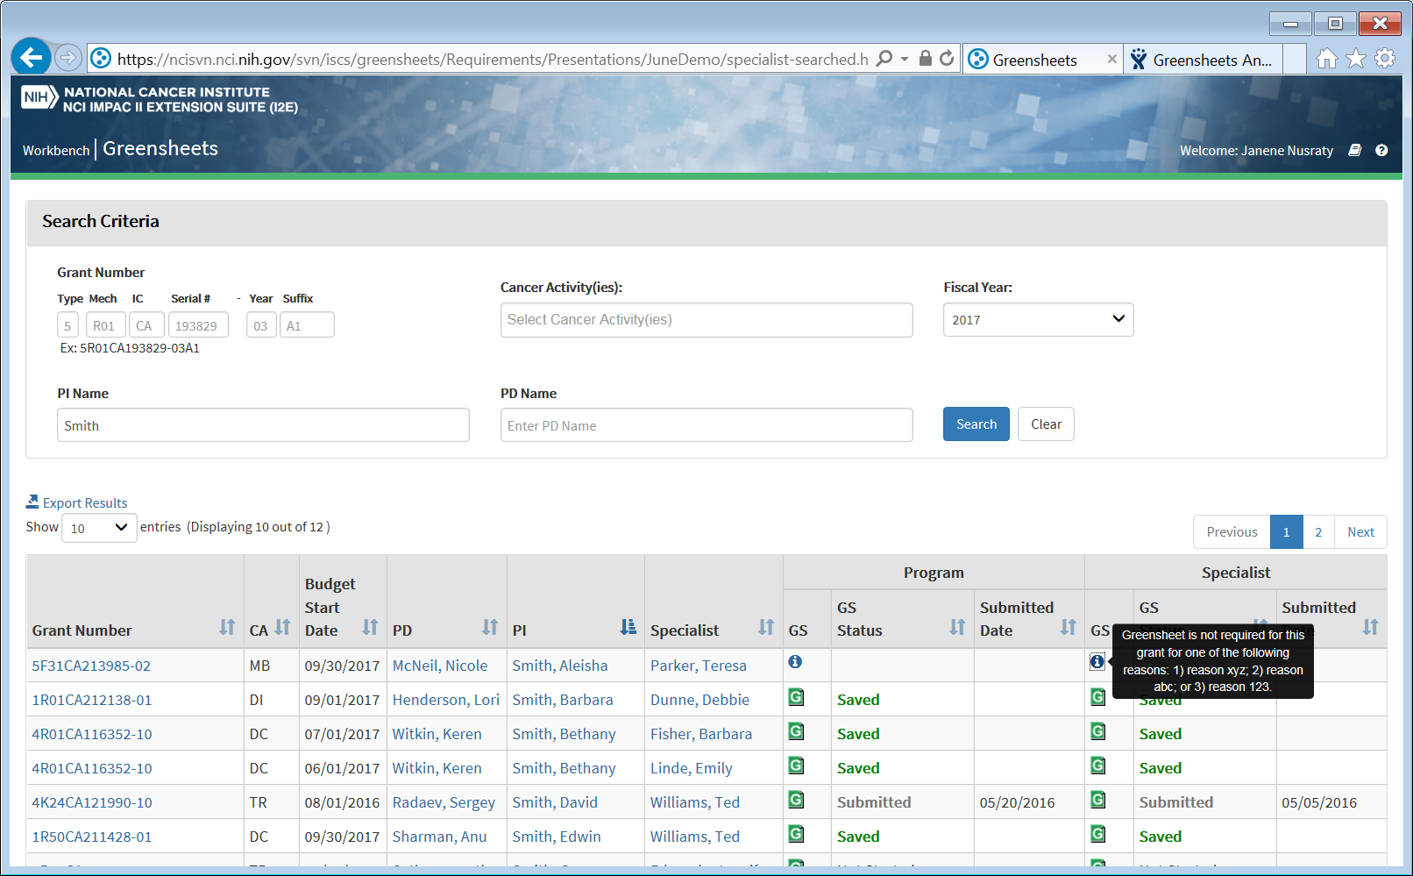

Program Search and Hitlist

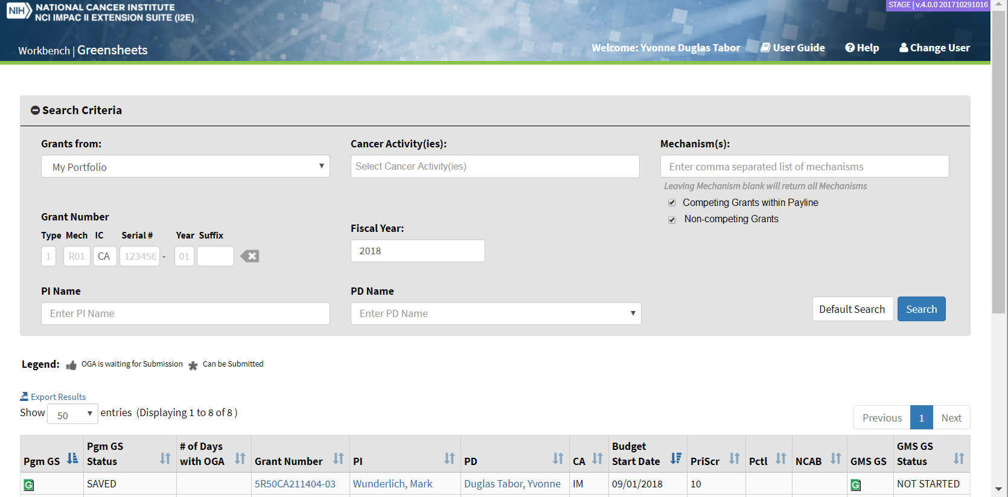
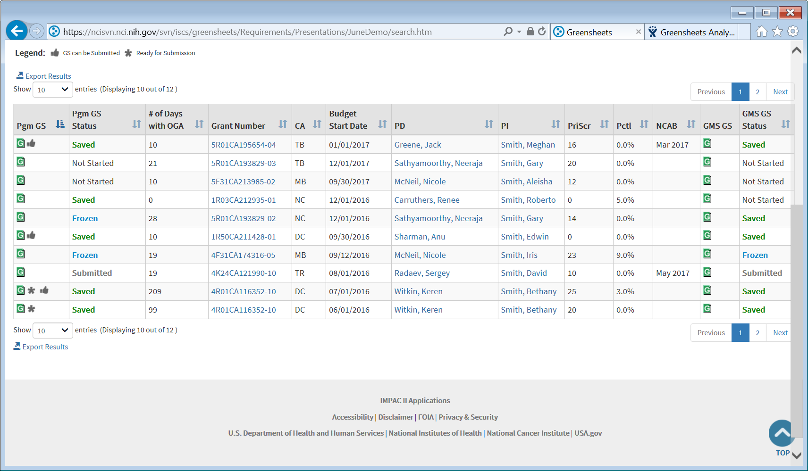

UI Specifications

Specialist/I2E User Search Criteria
Specialist view does NOT have default search criteria and/or default query. See sec. Business rules:
- General rules: what grants the search should bring?
Element Name | Description | Element Type | Comments
Grant Number | Allows search by grant number  Consists of:  Type  Mechanism  IC  Serial Number  Year  Suffix | Enterable fields | NOTE: ability to clear grant number should be provided  - Default: blank  User can enter one or more parameters:  - Type – Application type (1 character, valid values 1-9)  - Mechanism – activity code (3 characters, format <letter><two numbers> or <2 letters><number>, e.g. R01;  - IC – primary funding IC (2 characters). Should be always ‘CA’ (meaning that user can only search NCI grants)  - Serial Number-grant serial number (6 characters, e.g. 123456)  - Year – Support year of the grant, (2 characters)  - Suffix – can be two or 4 characters, e.g. A1 or A1S1
Cancer Activity(ies) | Allows search by one or more CA as search parameters | Dropdown | - Default: blank  - Range: all CA(s)
Fiscal Year | Allows search by FY | Enterable Field | - Default: blank  - Format: YYYY  - Validation on format is needed. Error message: “Please enter FY in YYYY format”  - Allow to enter only one FY (no multiples)
PI Name | Allows search by PI Name | Enterable Field | - Default: blank  - Case insensitive  - User can enter part of the name
PD Name | Allows search by PD Name | Dropdown | - Default: blank  - There is no need for ‘active PD” checkbox. Within this dropdown inactive PD should be at the bottom in the separate section and clearly indicated (e.g. by italic font like in Your Grants)
Search | Allows to perform the search per entered search parameters | Button
Clear | Allows to clear all search parameters; | Button

Specialist/I2E User Hit list
Ability to Export Hit List to Excel is provided (above and below the hit list)
Default sort by Budget Start Date; latest to the top
Element Name | Description | Element Type | Comments
Grant Number | Displays Grant Number | Hyperlink | Sortable by Grant number  Hyperlinked to Grant Detail information. The "Everything You Wanted To Know…" screen of "Your Grants" Application will open in a new browser window.
CA | Displays Cancer Activity for the grant | Read-only | Sortable in alphabetical order
Budget Start Date | Displays Budget Start Date for the grant | Read-only | Format MM/DD/YYYY  Sortable by date
PD | Displays Program Director’s name, assigned to a grant | Hyperlink | - Hyperlinked to user’s email client; “TO:” field should be pre-populated with email address of this PD  - Format: <Last Name>,<First Name>  - Sortable (by Last name first, secondary sort by First name)
PI | Displays Principal Investigator’s name of the grant | Hyperlink | - Hyperlinked to user’s email client; “TO:” field should be pre-populated with email address of this PI  - Format: <Last Name>,<First Name>  - Sortable (by Last name first, secondary sort by First name)
Specialist | Displays Primary Specialist’s name, assigned to a grant | Hyperlink | - Hyperlinked to user’s email client; “TO:” field should be pre-populated with email address of this Specialist  - Format: <Last Name>,<First Name>  - Sortable (by Last name first, secondary sort by First name)
Program
GS | Provides ability to navigate to Program greensheet | Icon
GS Status | Displays Program greensheet status | Read-only | Sortable in alphabetical order
Submitted Date | Displays Program greensheet Submitted Date | Read-only | Format MM/DD/YYYY  Sortable by date
Specialist
GS | Provides ability to navigate to Specialist greensheet | Icon
GS Status | Displays Specialist greensheet status | Read-only | Sortable in alphabetical order
Submitted Date | Displays Specialist greensheet Submitted Date | Read-only | Format MM/DD/YYYY  Sortable by date

Program Search Criteria
Program view has default search criteria and default query. See sec. Business rules:
- Rule for Program Search Criteria values
- General rules: what grants the search should bring?
- Additional rules for Program hitlist view
Element Name | Description | Element Type | Comments
Grants from | Allows search by pre-defined value | Dropdown | See sec. Business rules - Rule for Program Search Criteria values
Cancer Activity(ies) | Allows additionally filter search results by one or more CA(s) | Dropdown | - Default: blank  - See sec. Business rules - Rule for Program Search Criteria values
Mechanism | Allows additionally filter search results by one or more mechanisms | Dropdown | - Default: blank  - Display the text below the dropdown “Leaving Mechanism blank will return all mechanisms”
Competing Grants within the Payline | Allows additionally filter search results by competing grants only  Sometimes a payline is not set. OGA requirement: if there isn’t a payline for that Program Director’s portfolio (search parameters) – then all of the grants that fall within his/her portfolio should show in the list  From implementation point of view, the column in the view (within payline flag) has 3 value, Yes (above payline), No (Below payline) and Blank (payline is not set). If the checkbox is checked on the search screen, the system should bring all competing grants with Yes and Blank values. This way anything that does not yet have a payline set will have blank value and will be displayed. | Checkbox | - Default: checked
Non-competing Grants | Allows additionally filter search results by non-competing grants only  NOTE: non-competing grants don’t have a payline (the column in the view (within payline flag) has NULL value) | Checkbox | Default: checked
Grant Number | Allows additionally filter search results by grant number (whole or partial)  Consists of:  Type  Mechanism  IC  Serial Number  Year  Suffix | Enterable fields | NOTE: ability to clear grant number should be provided  - Default: blank  User can enter one or more parameters:  - Type – Application type (1 character, valid values 1-9)  - Mechanism – activity code (3 characters, format <letter><two numbers> or <2 letters><number>, e.g. R01;  - IC – primary funding IC (2 characters). Should be always ‘CA’ (meaning that user can only search NCI grants)  - Serial Number-grant serial number (6 characters, e.g. 123456)  - Year – Support year of the grant, (2 characters)  - Suffix – can be two or 4 characters, e.g. A1 or A1S1
Fiscal Year | Allows additionally filter search results by FY | Enterable Field | - Default: current FY  - Format: YYYY  - Validation on format is needed. Error message: “Please enter FY in YYYY format”  - Allow to enter only one FY (no multiples)
PI Name | Allows additionally filter search results by PI Name | Enterable Field | - Default: blank  - Case insensitive  - User can enter part of the name
PD Name | Allows additionally filter search results by PD Name | Dropdown | - Default: blank  - There is no need for ‘active PD” checkbox. Within this dropdown inactive PD should be at the bottom in the separate section and clearly indicated (e.g. by italic font like in Your Grants)
Search | Allows to perform the search per entered search parameters | Button
Reset to Default Search | Allows to reset default search parameters and re-run default query | Button

Program Hit List
Ability to Export Hit List to Excel is provided (above and below the hit list)
Default sort by icons in Pgm GS; secondary by Budget Start Date (ascending)
Element Name | Description | Element Type | Comments
Legend | Displays icons’ legend | Read-only | - Can be Submitted  - OGA is waiting for Submission
Pgm GS | Allows to navigate to Program Greensheet;  Displays additional information via icons (,). For the rules, see sec. Business rules => Icons in Program Hit List | Icons | Sortable by icons  Default):  , - grouped together to the top;  After that  After that without icons  Secondary sort by Budget Start Date ascending
Pgm GS Status | Displays Program greensheet status | Read-only | Sortable in alphabetical order
# of Days with OGA | See sec. Business Rules => # Days in GPMATS | Read-only | Sortable
Grant Number | Displays Grant Number | Hyperlink | Hyperlinked to Grant Detail information. The "Everything You Wanted To Know…" screen of "Your Grants" Application will open in a new browser window.  Sortable by grant number
CA | Displays Cancer Activity for the grant | Read-only | Sortable in alphabetical order
Budget Start Date | Displays grant Budget Start Date | Read-only | Format MM/DD/YYYY  Sortable by date
PD | Displays Program Director’s name, assigned to a grant | Hyperlink | - Hyperlinked to user’s email client; “TO:” field should be pre-populated with email address of this PD  - Format: <Last Name>,<First Name>  - Sortable (by Last name first, secondary sort by First name)
PI | Displays Principal Investigator’s name of the grant | Hyperlink | - Hyperlinked to user’s email client; “TO:” field should be pre-populated with email address of this PI  - Format: <Last Name>,<First Name>  - Sortable (by Last name first, secondary sort by First name)
PriScr | Displays grant Priority Score | Read-only | Sortable  NOTE:  Gaby: it looks like we are copying priority score of a parent competing grant into subsequent years of non-competing grants.  Doug: That data is coming right out of form_grant_vw; (the ultimate source is NCI_STAGE.PV_GRANT_PI_T). I can’t see any special handling of type 5 grants in the view definition.
Pctl | Displays grant percentile | Read-only | Sortable  NOTE: same process of copying %-le into non-competing grants as for priority score
NCAB | Displays Board Date | Read-only | Format “month year” (like Jun 2016)  Sortable by date  This is a council meeting date (review), therefore it exists for competing grants only  Council meetings are held in January, May, August or October. These are valid values for the Month.  For non-competing grants this value should be blank.
GMS GS | Allows to navigate to Specialist Greensheet; | Icon
GMS GS Status | Displays Specialist Greensheet Status | Read-only | Sortable in alphabetical order

REPORTING REQUIREMENTS
None

Additional requirements

Ability to paste grant number in search parameters
Dev team should investigate the possibility to pasting grant number into grant number search parameters.
NOTE: Greensheets system allows search only NCI grants. If user is trying to paste non-NCI grant, an error message should be displayed “You can only search NCI grants”

